Nature Retreat XXIX

The Wood Duck

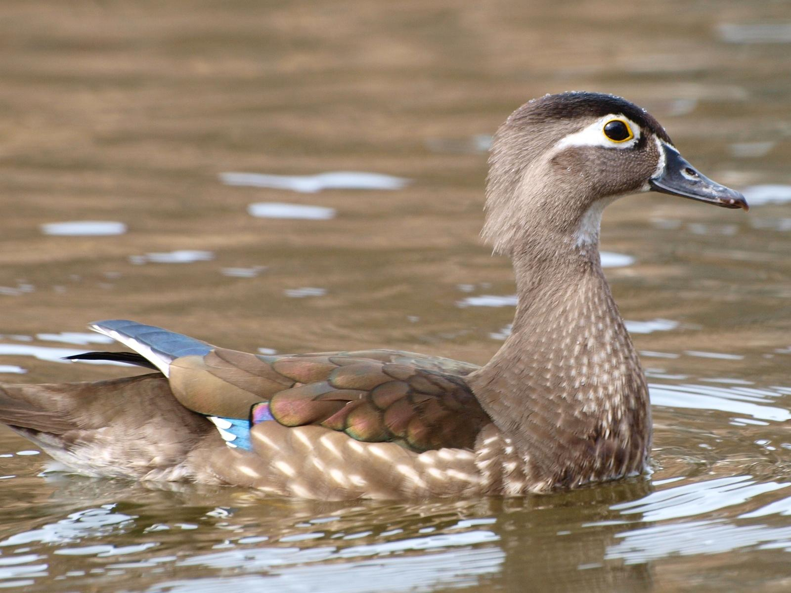

Sermon Outline

Job 12:7—“Born To Die!”

I. Leaving The Nest

II. Born To Die

lll. The Mother Hen

IV The Leap Of Faith

V The Holy Spirit

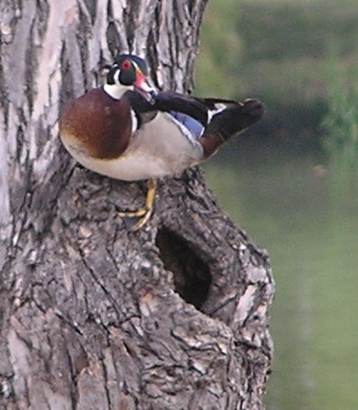

Born
To

Die

20 September 2020

Nature Retreat XXIX

Water Of Life

The Wood Duck

Order of Service:

Opening Hymn: How Great Thou Art, CW 256

Reading: John 3:1-13

Song by Matt & Erin Kelly: The Wind And The Spirit

Sermon Hymn: Let All things Now Living, CW 260

Sermonette: Job 12:7

Born To Die

The Lord’s Prayer

Closing Hymn: God Be With You, CW 327

Nature Retreat XXIX

We live in an area of intense natural beauty. And it was 26 years ago that Christine and I hit on the idea of sharing our section of God’s Country over an open Bible with Christian friends who had a love for nature and the Word of God.

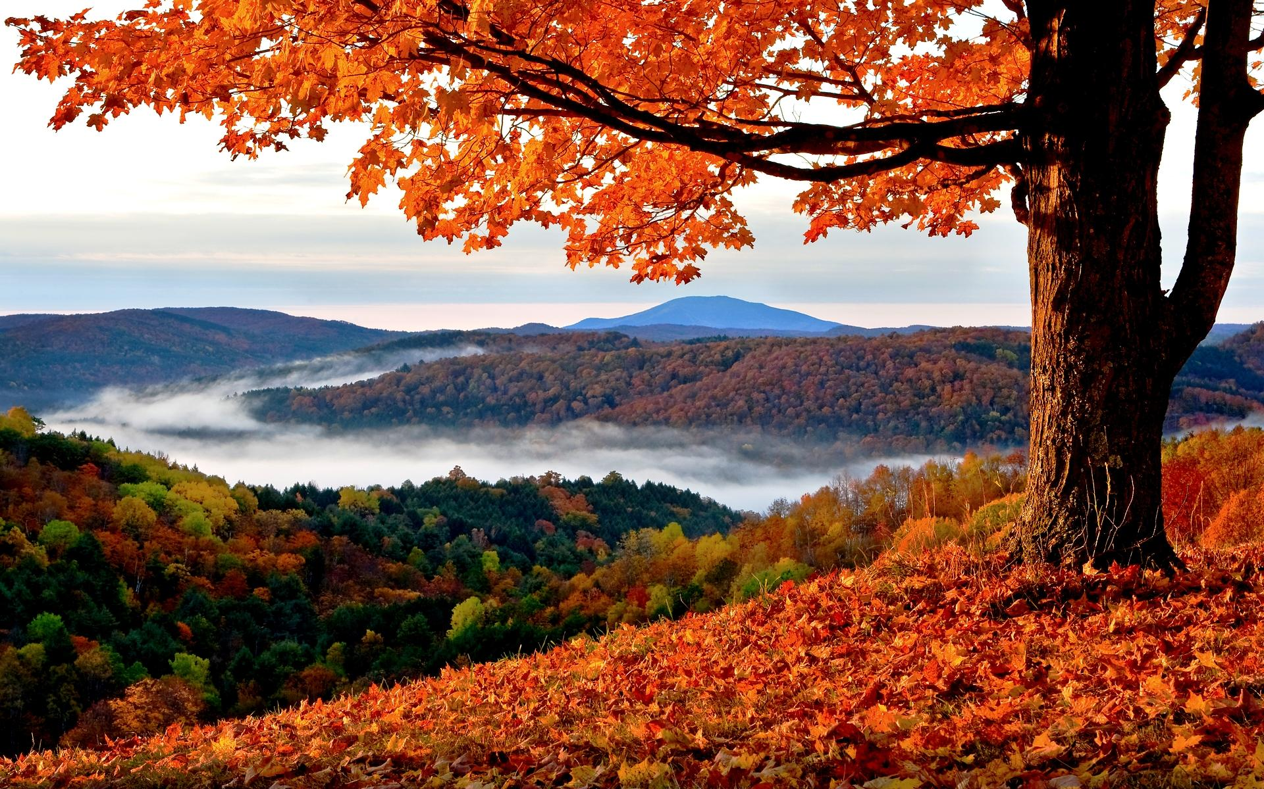

Looking back over the years, there are so many pleasant memories we have of our Nature Retreats. Old friendships have been renewed and new friendships have been formed. And we have been blessed with good weather every single time.

Over the years we have had contact with the hills and the clouds; with the Monarch Butterfly and the Scarlet Worm; with the Sun, Moon, and Stars; with Eagles and the Great Horned Owl; with the Great Pyramid of Egypt; with the Loon and the Arctic Tern; with Ants and Snowflakes; with the Sea and the Northern Lights.

The Lord God’s creation, speaking to us from the pages of the Volume of Nature. And from the light found in the Volume of Holy Scripture.

